**Understanding Cloud Organization using Deep Learning**

Devasenan M   
Computer Science and Engineering  
Kumaraguru College of TechnologyCoimbatore, India  
devasenan.20cs@kct.ac.inKaran J  
Computer Science and Engineering  
Kumaraguru College of TechnologyCoimbatore, India  
karan.20cs@kct.ac.in

Shivaramakrishnan R  
Computer Science and Engineering  
Kumaraguru College of TechnologyCoimbatore, India  
shivaramakrishnan.20cs@kct.ac.in

***Abstract*— Humans are top-notching at detecting interesting patterns in images, primarily the geo-sat images from the satellite. However, it is often difficult to gather enough data of subjective features for experimental analysis. This paper presents an example of how two tools that have recently become accessible to a wide range of researchers, crowd-sourcing and deep learning, can be combined to explore satellite imagery at scale. Although they are difficult to interpret and represent in a climate model, shallow clouds are crucial to understanding the Earth's climate. By categorizing these cloud patterns, it is possible to better understand their physical makeup, which would enhance the creation of climate models and enable better predictions of climate change or weather forecasts. In particular, the focus is on the organization of shallow cumulus convection in the trade wind arid regions. Shallow clouds often play a large role in the Earth's radiation balance yet are poorly represented in climate models. For this project four subjective patterns of organization were defined including Sugar, Flower, Fish and Gravel. Cloud labeling has been implemented at two institutes, 67 scientists screened 10,000 satellite images on a geo-sat crowd-sourcing platform and classified almost 50,000 mesoscale cloud clusters. The dataset is then accumulated as a training dataset for deep learning algorithms to make it possible to automate and normalize the pattern detection and create global climatologies of the respective four patterns. Observations of the geographical distribution and large-scale environmental conditions suggest that each of the four patterns overlaps with established modes of organization, but also differs from them. As well, this study illustrates and clarifies the proportionality of crowdsourcing and deep learning for exploration of geosat data.**

**Keywords- CrowdSourcing, cloud labeling and cellular convection.**

**Introduction**

Clouds perform an essential role to control the radiation of the sun as well as controlling the radiation that goes back to the atmosphere. The more energy that is trapped inside the planet, the warmer the atmosphere becomes, giving rise to sea level via meltdown of polar ice caps and contributing to global warming. The less energy that is trapped, the colder the temperature becomes. Understanding the structure of the clouds gives a better insight into the planet’s weather.

A spontaneous glance at an image, be it extracted from a satellite or produced from the output of the model, is often adequate for a scientist to identify features of interest. Similarly monotonous features across many images form the basis for identifying patterns. This human ability to identify patterns has a greater impact and also in situations where the features, let alone the patterns they build, are difficult to describe objectively a situation which frustrates the development of explicit and objective methods of pattern identification and extraction. In these situations, machine learning techniques, particularly deep learning have demonstrated their ability to mimic the human capacity for identifying patterns, also from satellite cloud imagery.

**NASA Dataset**

The prevalence of mesoscale patterning in satellite cloud imagery led the ISSI team to identify four cloud patterns that frequent the lower trades of the North Atlantic. They named these patterns Sugar, Flower, Fish and Gravel (Fig. 1). The choice of new and exclusive names was motivated by the judgment that the patterns were different than those that have been previously described, for instance in studies of stratocumulus or cold-air outbreaks. When ISSI team applied to the scenes classified by the the algorithm mostly resulted in the \disorganized" classification. Despite the lack of a simple link between the patterns classified by the ISSI team and patterns previously described in the literature, below we point out previously identified patterns that may be related to the four patterns used here.

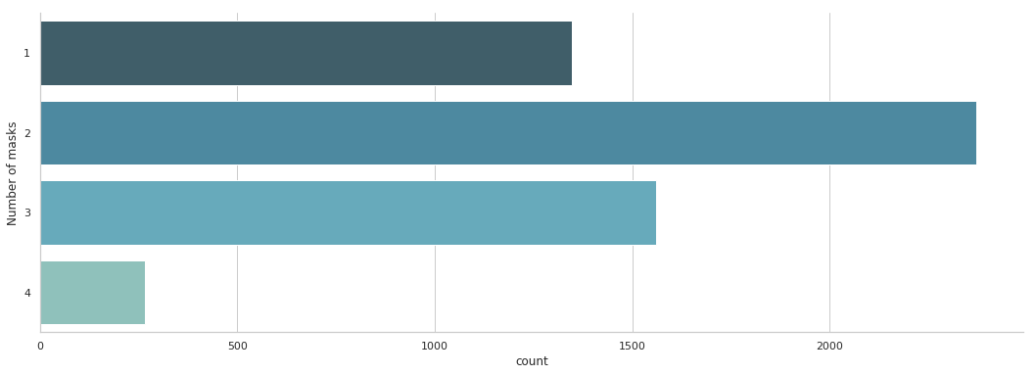

“Sugar" describes widespread areas of very fine cumulus clouds. Overall these elds are not very reflective, do not have large pockets of cloud-free regions and, ideally, exhibit little evidence of meso-scale organization. Often, though, they are embedded within the larger-scale flow which gives them some structure. In strong flow, Sugar can form thin "veins", or feathers, which have previously described as dendritic clouds (Nicholls and Young, 2007).

The contribution of the paper are listed as follows: Looking into the above concerns, a number of models have been constructed which are further more coherent and meticulous, the models are trained, tested and are referenced in this paper

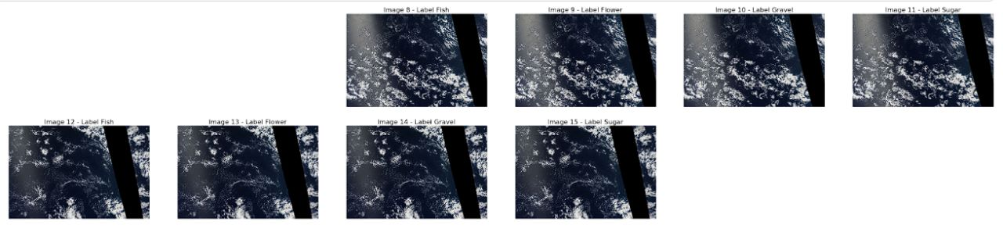

“Flowers” are those areas with isotropic cloud structures, each ranging from 50 to 200 km in diameter, with similarly wide cloud-free regions in-between. This pattern overlaps to some degree with canonical closed- cell MCC.

Flowers, however, are often less densely packed than typical closed cells, which only have nar- row cloud-free regions at the edges, and they are iden- tified well outside of regions where stratocumulus are found (Norris, 1998). One hypothesis is that they are successors of more closely packed closed-cell MCC which are in the process of breaking up.

“Fish” are elongated, skeletal structures that some- times span up to 1,000 km, longitudinally in precise. As noted by Stevens et al. (2019b), these features appear similar to what Garay et al. (2004) called actinoform clouds. They presented examples of these semantic well structured cloud forms taken from all ocean basins, near but typically downwind of regions where stratocumulus maximize. To the extent Fish are variants of the actinoform clouds found by Garay et al., they may be more common than previously thought.

Finally, “Gravel” describes fields of granular features marked by arcs or rings. The typical scale of these arcs are around 20 km. We suspect that these patterns are driven by cold pools caused by raining cumulus clouds (Rauber et al., 2007). In this re- gard, Gravel is fundamentally different from open-cell MCC, which has larger cells that are driven by over- turning circulations in the boundary layer. However, the line between these two mechanisms can blur at times.

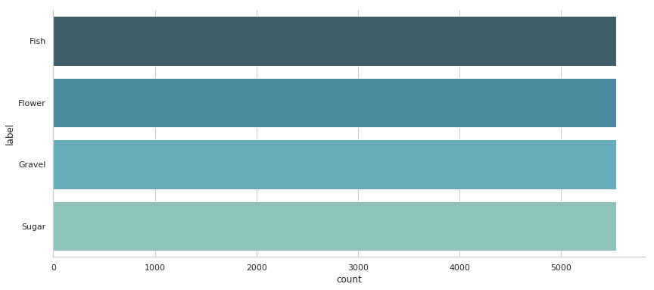

It is also interesting to compare our subjectively chosen labels to those of Denby (2020) who used an unsupervised learning algorithm to automatically de- tect different types of cloud organization (their Fig. 2). Some of their patterns bear resemblance to our classes, e.g. ”Sugar” seems to most closely correspond to their patterns A and B, ”Gravel” to G and H. How- ever, their automatically detected classes appear less striking to the human eye.

# **Methodology**

In this paper, we described a project to combine crowd-sourcing, to detect and label four subjectively defined patterns of mesoscale shallow cloud organization from satellite images, with deep learning. The design and execution of the project raised a number of questions, four of which have been highlighted in this paper, and the answers to which we present as follows.

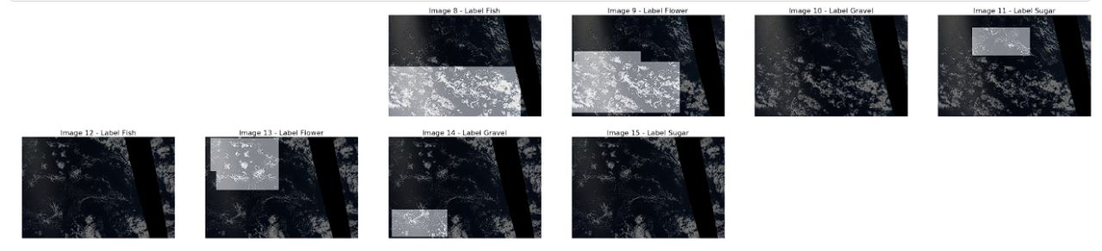

Drawing crude rectangles on the screen only took tens of seconds for each image, whereas more detailed shapes such as polygons would have taken significantly longer. Further, the quickness of drawing boxes on an image meant that less of an attention span was required from the participants. (Some even reported to have had fun.) For our task, which involves judgements with inherent uncertainty, the added noise introduced by crude labels turned out to be insignificant in the statistical average, as shown by the “consensus” found by the deep learning algorithm. Based on our experience, quantity trumps quality. This might, of course, be different for tasks where object boundaries are more clearly defined.

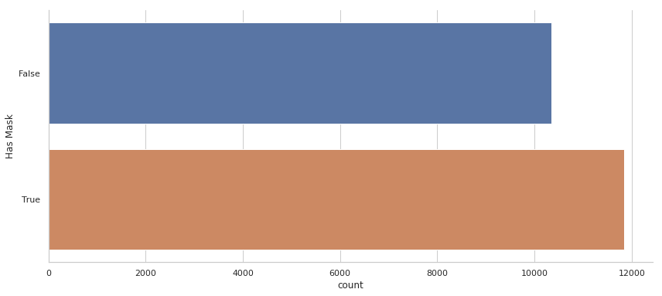

We believe that this is indeed the case. As discussed in the section titled ”Inferences from human labels” there is a significant amount of disagreement between the participants, particularly because many cloud formations did not fit one of the four classes exactly. However, more importantly there was significant agreement on patterns that closely matched the canonical examples of “Sugar”, “Flower”, “Fish” and “Gravel”. Taking a statistical average – training a deep learning model can be viewed as doing just that – removes some of the ambiguity from the labels and crystallizes the hu- man consensus.

Of course, the four classes chosen are not a complete description of all modes of orga- nization, and others could have been defined. But the fact that the results are compatible with physical understanding suggest that the four classes do indeed capture important modes of cloud organization in the sub-tropics.

**Deep Learning technique**

Deep learning describes a branch of artificial intelligence based on multi-layered artificial neural networks (Nielsen, 2015). In recent years, this data-driven approach has revolutionized the field of computer vision which up to 2012 was to a large extent based on hard-coded feature engineering (LeCun et al., 2015). More specifically, the success of deep learning in vision tasks is based convolutional neural networks which exploit the translational invariance of natural images (i.e. a dog is a dog whether it is in the top right or bottom left of the image) to greatly reduce the number of unknown parameters to be fitted.

 

Deep neural networks also have many potential applications in the Earth sciences, particularly where already existing deep learning techniques can be transferred to geoscientific problems. Since the dataset was gathered from a public Kaggle competition, there were two sets of scores that competed among others. Public LB1 scores are those which are shown while the competition is ongoing. It shows the outcome from a subset of the test dataset. Private LB scores get generated after the competition is over, that provides scores on the remaining test dataset. As a result, public LB scores are usually better than the private. For this particular competition, a private score was calculated on 75% of the test data.



We opted for the rectangles to increase labeling speed and improve the user experience. Our thinking was that it would be better to have less accurate but more plentiful data, and that given the vague boundaries of the cloud structures, it was anyway doubtful that a more accurate labeling tool would add much information. As we will show later, this thinking paid off for the machine learning models we trained.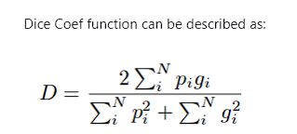

Every architecture has similarity with its earlier versions. The only difference is the different feature maps that increase the number of parameters. All the models have the same architecture as its previous one, except for the multiplied block (x2) that expands and covers more blocks. This gives a lot of parameters to be used in a calculation, making it a very robust model. It’s not difficult to observe the changes among all the models, and they gradually increased the number of sub-blocks.

Efficient Net was prioritized in this paper due to limitations of Kaggle notebook as well. It was also the core reason why the remaining Efficient Net models were avoided, since they calculate a substantial amount of parameters, which takes a lot of processing power and time, producing a disappointing outcome. While calculating mVA for Efficient Net models, fine-tuning has been applied alongside baseline versions for each models.

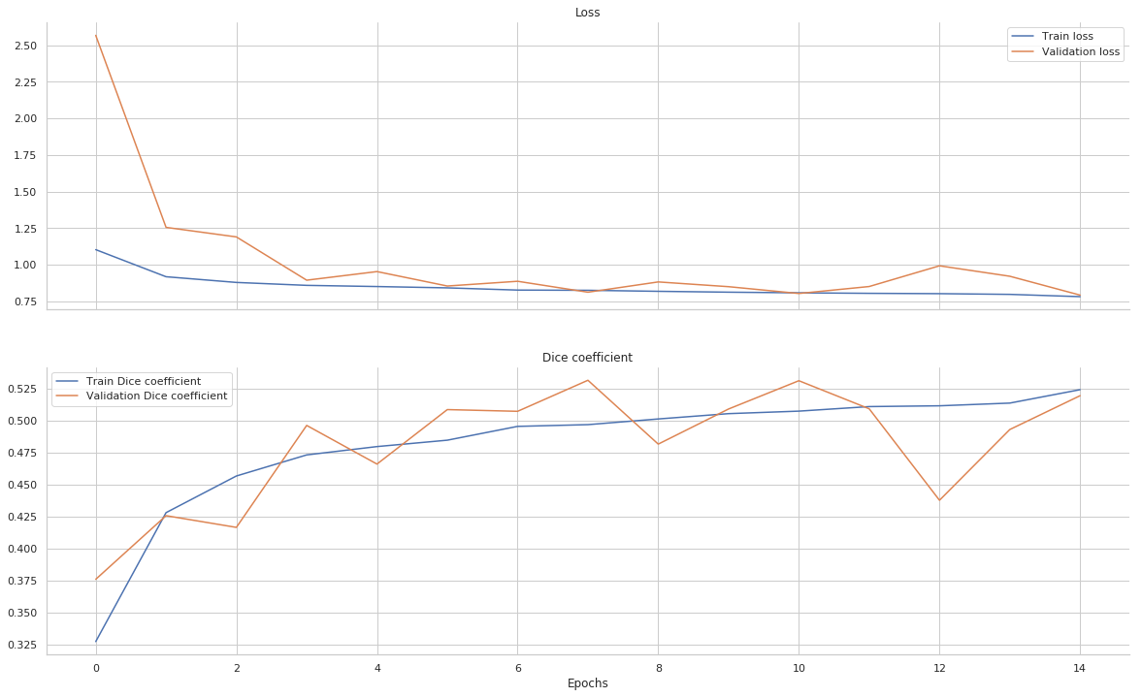

The main objective of this experiment was to express in a meaningful manner that EfficientNet alone doesn’t provide a satisfying outcome in a dataset like this, despite being a substantially efficient classification layer.

We showed in our research that by initiating a different segmentation architecture like UNet alongside EfficientNet, we can improve the performance on datasets like the one used in this project. It is also worth noting that instead of using UNet as a segmentation architecture alone, we used EfficientNet’s encoding capability and realized that EfficientUnet shows significant improvement on the outcome. By using a classification layer as an encoder and a segmentation architecture as decoder, we boosted the performance of both the models and made them work together for a better performance

# **Conclusion**

The coherence of the heat maps for individual patterns suggests the presence of physical drivers underpinning their occurrence; drivers that may change as the climate changes. Using the same classifica- tion categories but a different way of classifying the images, Bony et al. (2019) showed that differences in cloud radiative properties are associated with dif- ferent forms of organization.

Our study thus lends weight to the idea that quantifying the radiative ef- fects of shallow convection, and potential changes with warming, may require an understanding of, or at least ability to represent, the processes responsible for the mesoscale organization of fields of shallow clouds. This might seem to be a daunting task.

In order to further increase the accuracy of the scoring process, the remaining 25% of the test data was withheld for validation purposes, to ensure that the final e score was accurate and consistent.

However, if the occurrence of different modes of organization can be reliably linked to large-scale conditions, reanaly- sis data or historical climate model simulations could help reconstruct cloud fields. This could offer clues as to how meso-scale organization, and hence cloudi- ness, has changed in the past, and may change in the future.

**References**

Arakawa, A., and W. H. Schubert, 1974: Interaction of a

Cumulus Cloud Ensemble with the Large-Scale Environ-

ment, Part I. Journal of the Atmospheric Sciences, 31 (3),

674{701, doi:10.1175/1520-0469(1974)031h0674:IOACCEi2.

0.CO;2.

Bony, S., H. Schulz, J. Vial, and B. Stevens, 2019: Sugar,

Gravel, Fish and Flowers: Dependence of Mesoscale Pat-

terns of Tradewind Clouds on Environmental Conditions.

Geophys. Res. Lett., 1{20{ submitted.

Bony, S., and Coauthors, 2017: EUREC4A: A Field Campaign

to Elucidate the Couplings Between Clouds, Convection and

Circulation. Surveys in Geophysics, 38 (6), 1529{1568, doi:

10.1007/s10712-017-9428-0.

Bretherton, C. S., 2015: Insights into low-latitude cloud feed-

backs from high-resolution models. Philosophical Transac-

tions of the Royal Society A: Mathematical, Physical and

Engineering Sciences, 373 (2054), 20140 415.

Chollet, F., and Others, 2015: Keras. <https://keras.io/>.

Denby, L., 2020: Discovering the importance of mesoscale cloud

organization through unsupervised classication. Geophysi-

cal Research Letters, 47 (1), e2019GL085 190.